Facebook Smart View

Specification Document

**Feature Explanation**

# Top 4 Popular Photos

This feature shows the user his “Top popular” photos.

We scan all the user photos, in all of the users’ albums, and give each photo a score. The score is calculated 60% from the likes on that photo, and 40% others from the number of comments on that photo.

After the scan is complete, we show the user his top 4 photos.

Later, the user can select a photo, from the photos shown under the feature panel, and Like it and/or comment the photo.

This ranking feature does not exist on Facebook, getting the “Top liked” or “Top commented” photos is done manually.

# News Feed Text Filtering

The feature gives you the ability to filter posts in your news feed.

The user has the option to create different filter groups.

For each group the user can add text items which will be removed from the news feed.

Furthermore, the user has the option to remove unnecessary item and groups and can decide whether to enable or disable the feature on the news feed.

For Example, if the user doesn’t want to see any series spoilers, the user will create a “spoilers” group and will add item such as: “Game of Thrones”, “Marvel”, etc.

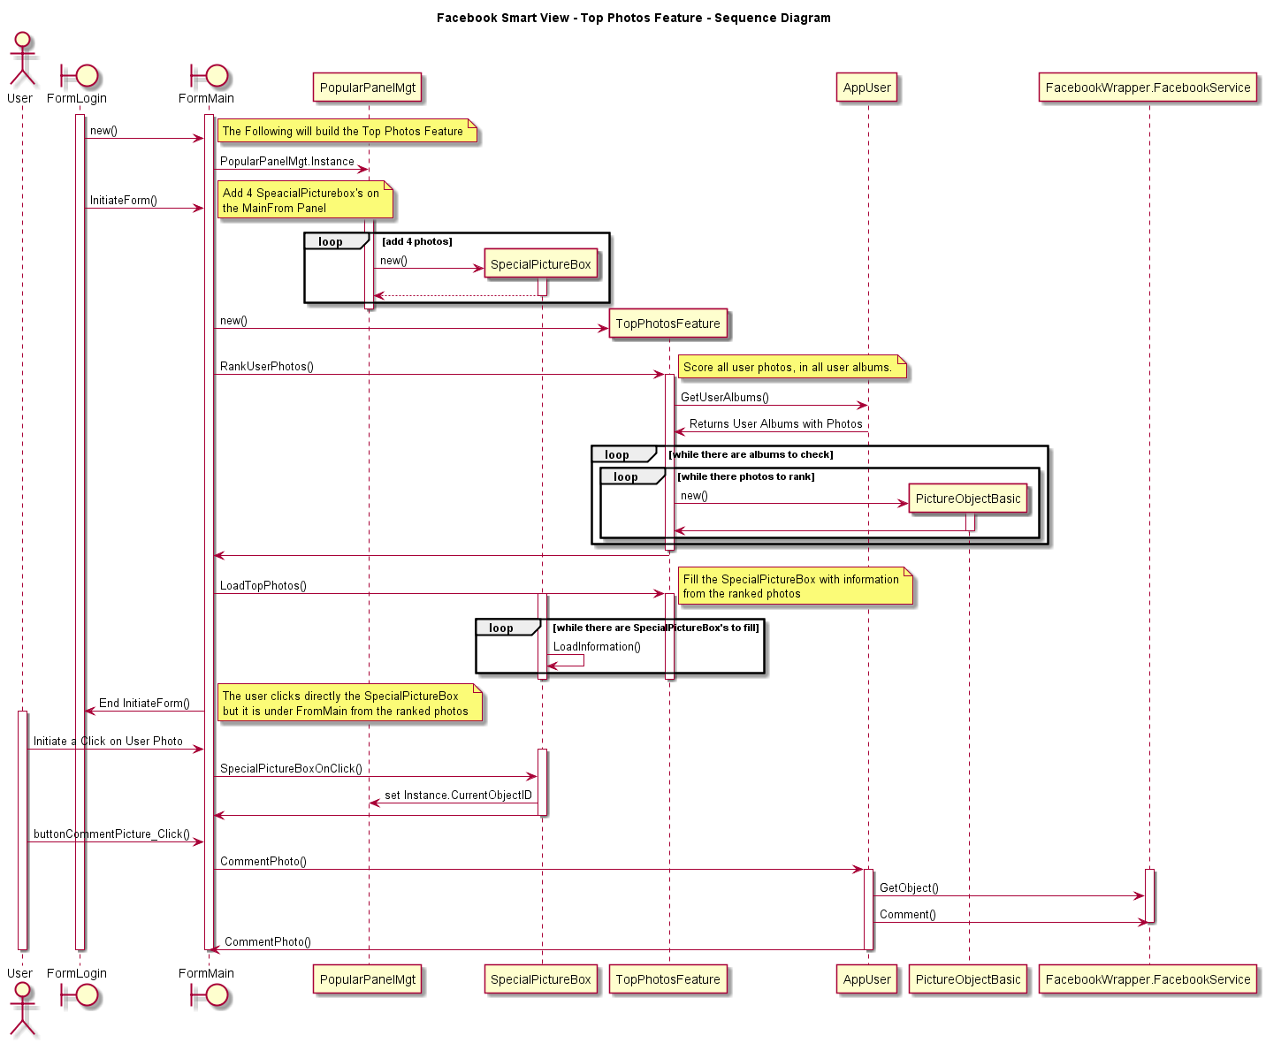Sequence Diagrams

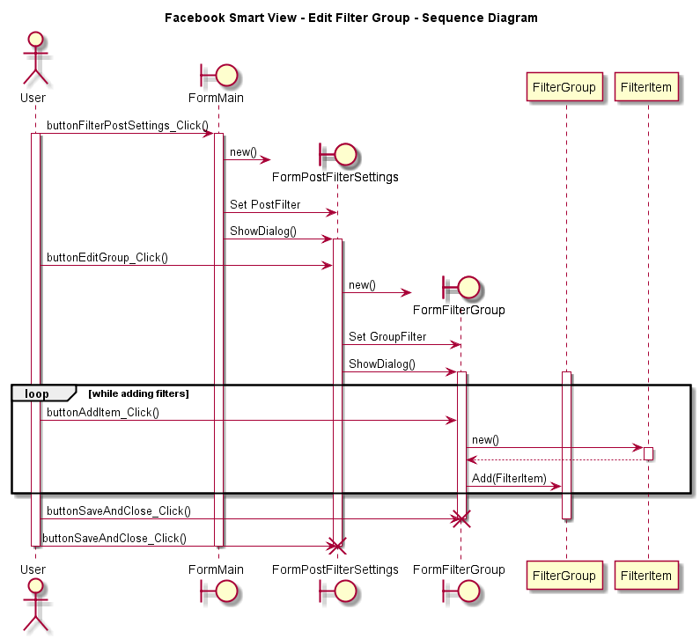

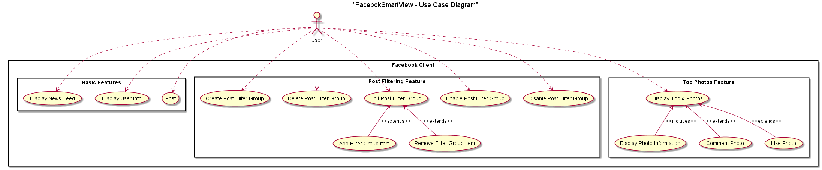Use Case Diagram

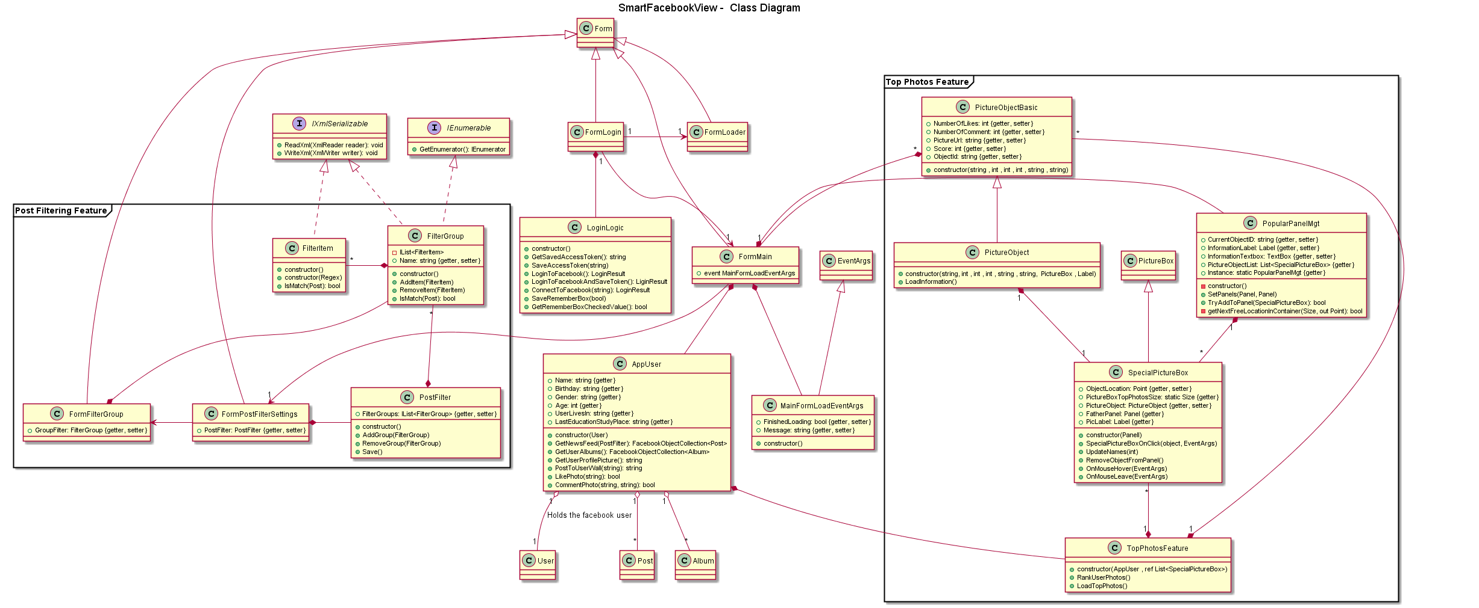Class Diagrams